

40th Annual General Meeting
June 24-28, 2018
John McIntyre Conference Center and the
University of Edinburgh
Edinburgh, Scotland
Professor Wilson Poon Host
University of Edinburgh

40th AGM Notes and Directions
Like our previous AGM in Philadelphia I was not able to find a combined Hotel and Meeting Venue in the same building or site. While we were able to find very reasonable room rates, we will be splitting our meeting into two parts: 1) the first three days will be held in the John McIntyre Conference Center that is adjacent to our hotel accommodations and 2) the last two days will be held at the King’s Buildings Complex on the University of Edinburgh campus (Sanderson Building on Wednesday and James Clerk Maxwell Building on Thursday). I will be providing bus transportation for the Wednesday meeting, but we will be walking for the Thursday meeting (bring comfortable shoes for the meeting). Below I have attached maps for the sites that we will be walking to:
1) Saturday June 23th for the Pre-Meeting Happy Hour
Salisbury Arms
58 Dalkeith Road
Edinburgh EH16 5AD
44-131-667-4518

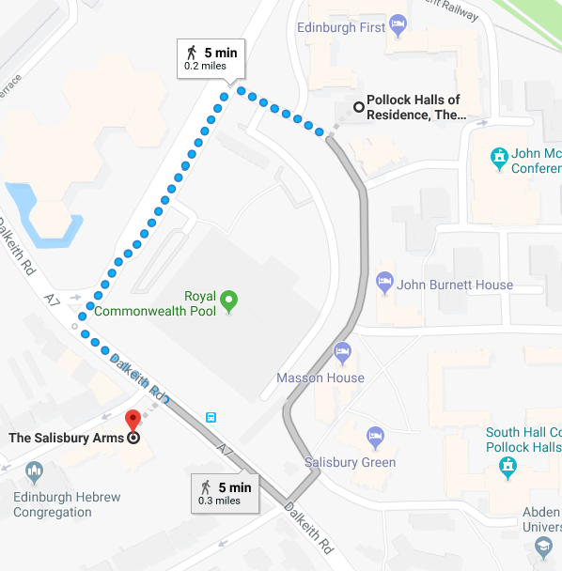

2) Sunday June 24th for the Official Welcome Cocktail Hour and Whisky Tasting
Dynamic Earth Ozone
112 Holyrood Road
Edinburgh EH8 8AS
44-131-550-7800
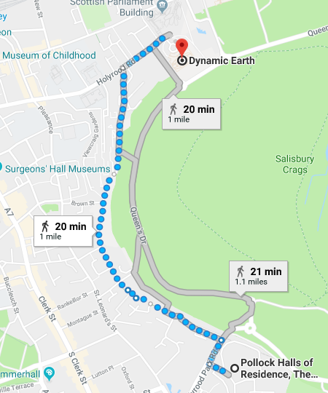

3) Wednesday June 27th for the AGM Meeting and Student Poster Presentations (Bus Provided) Sanderson Building and Thursday June 28th for the AGM Meeting (Walking Required) James Clerk Maxwell Building
Sanderson Building, University of Edinburgh
Robert Stevenson Road, King’s Buildings
Edinburgh EH9 3FB
44-131-650-1000

James Clerk Maxwell Building, University of Edinburgh
Peter Guthrie Tait Road, King’s Buildings
Edinburgh EH9 3FD
44-131-650-5830

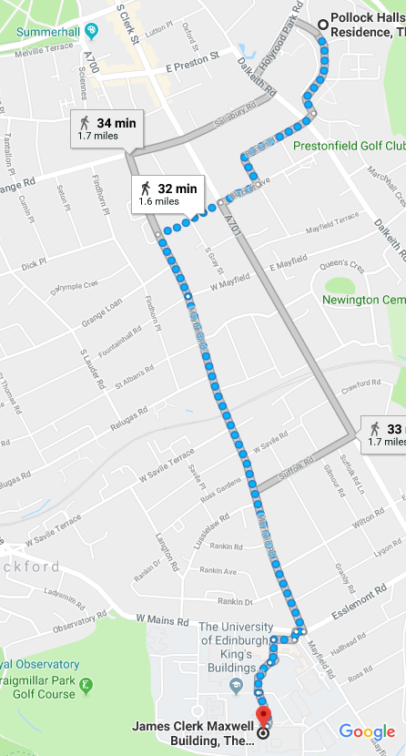
 | Saturday June 23rd
Happy Hour |  |  |  |  | Salisbury Arms
Members, Academics, Consultants, Guests, Accompanying Persons |  |  |  |  |  |  |  |  |  |  |  |  |  |  |  |  |  |  |  |  |  |  |  |  |  |  |  |  |  |  |  |  |  |  |  |  |  |  |  |  |  | 1800-2000
 | Sunday June 24th
Breakfast |  |  |  |  | Café Lower Level John McIntyre Conference Center
Members, Academics, Consultants, Guests, Accompanying Persons |  |  |  |  |  |  |  |  |  |  |  |  |  |  |  |  |  |  |  |  |  |  |  |  |  |  |  |  |  |  |  |  |  |  |  |  |  |  |  |  |  | 0630-1000
Registration |  |  | Foyer John McIntyre Conference Center
Members, Academics, Consultants, Guests |  |  |  |  |  |  |  |  |  |  |  |  |  |  |  |  |  |  |  |  |  |  |  |  |  |  |  | From 0800
Opening Business Meeting |  |  |  |  |  |  |  |  |  | Pentland John McIntyre Conference Center
Members, Consultants |  |  |  |  |  |  |  |  |  |  |  |  |  |  |  |  |  |  |  |  |  |  |  |  |  |  |  |  |  |  |  | Willie Hendrickson, Chair
 | 0830 |  | Call to Order |  |  |  |  |  |  |  |  |  |  |  |  |  |  |  |  |  |  |  |  |  |  |  |  |  |  |  |  | Willie Hendrickson (IFPRI)
 | 0840 |  | Reading of Minutes from Last Meeting |  |  |  |  |  |  |  |  |  |  |  |  |  |  |  |  |  |  |  |  |  |  |  |  |  |  |  |  | Matt Maille (KGM)
 | 0850 |  | Financial Status and Budget |  |  |  |  |  |  |  |  |  |  |  |  |  |  |  |  |  |  |  |  |  |  |  |  |  |  |  |  | Willie Hendrickson (IFPRI)
 | 0910 |  | Membership Status and Invited Guests |  |  |  |  |  |  |  |  |  |  |  |  |  |  |  |  |  |  |  |  |  |  |  |  |  |  |  |  | Willie Hendrickson (IFPRI)
 | 0940 |  | Communication Report |  |  |  |  |  |  |  |  |  |  |  |  |  |  |  |  |  |  |  |  |  |  |  |  |  |  |  |  | Matt Maille (KGM)
 | 1000 |  | Coffee Break
 | 1015 |  | Technical Program Status |  |  |  |  |  |  |  |  |  |  |  |  |  |  |  |  |  |  |  |  |  |  |  |  |  |  |  |  | Judith Bonsall (Unilever)  Jim Michaels (IFPRI)
 | 1100 |  | Planning and Other Business |  |  |  |  |  |  |  |  |  |  |  |  |  |  |  |  |  |  |  |  |  |  |  |  |  |  |  |  | Willie Hendrickson (IFPRI
Lunch |  |  |  |  |  |  |  |  |  |  | Centro Area John McIntyre Conference Center
Members, Academics, Consultants, Guests |  |  |  |  |  |  |  |  |  |  |  |  |  |  |  |  |  |  |  |  |  |  |  |  |  |  |  |  |  |  |  | 1130-1230
Welcoming Lunch for Prospective and First-Time IFPRI Members
AGM Welcome, IFPRI Reviews and Workshop Report |  |  |  |  |  |  |  |  |  |  |  |  |  |  |  |  |  |  | Pentland John McIntyre Conference Center
Members, Academics, Consultants, Guests |  |  |  |  |  |  |  |  |  |  |  |  |  |  |  |  |  |  | Judith Bonsall (Unilever), Chair
 | 1230 |  | Welcome and Introduction of Guests |  |  |  |  |  |  |  |  |  |  |  |  |  |  |  |  |  |  |  |  |  |  |  |  |  |  |  |  |  |  |  |  |  |  |  | Willie Hendrickson (IFPRI)
 | 1240 |  | Opening Comments |  |  |  |  |  |  |  |  |  |  |  |  |  |  |  |  |  |  |  |  |  |  |  |  |  |  |  |  |  |  |  |  |  |  |  | Judith Bonsall (Unilever)
 | 1250 |  | From Powder to Suspension and Granules: Towards a Unified Treatment of Liquid Incorporation |  |  |  |  |  |  |  |  |  |  |  |  |  |  |  |  |  |  |  |  |  |  |  |  |  |  |  |  | Wilson Poon (University of Edinburgh –UK)
 | 1330 |  | Grinding Aids Review |  |  |  |  |  |  |  |  |  |  |  |  |  |  |  |  |  |  |  |  |  |  |  |  |  |  |  |  | Arno Kwade (Universität Braunschweig – Germany)
 | 1410 |  | Boundary Layers in Multi-Phase Flow Review |  |  |  |  |  |  |  |  |  |  |  |  |  |  |  |  |  |  |  |  |  |  |  |  |  |  |  |  | Roger Bonnecaze (University of Texas at Austin - USA)
 | 1450 |  | IFPRI Status and Forward Framework for the Systems Engineering Area |  |  |  |  |  |  |  |  |  |  |  |  |  |  |  |  |  |  |  |  |  |  |  |  |  |  |  |  |  |  |  |  |  |  | Satoru Watano (Osaka Prefecture) Paul Mort (IFPRI)
 | 1530 |  | Coffee Break
 | 1600 |  | Wet Systems Workshop – Feedback |  |  |  |  |  |  |  |  |  |  |  |  |  |  | John Hone (Syngenta)  Marty Murtagh (Corning)
 | 1630 |  | DEM Round Robin Update |  |  |  |  |  |  |  |  |  |  |  |  |  |  |  |  | Massih Pasha (Chemours)
 | 1700 |  | IFPRI Education Update |  |  |  |  |  |  |  |  |  |  |  |  |  |  |  |  |  |  |  |  |  | Jim Michaels (IFPRI)
 | 1730 |  | Adjourn
Welcoming Happy Hour and Whisky Tasting |  |  |  |  |  |  |  |  |  |  |  |  |  |  |  |  |  |  |  |  |  |  |  |  |  |  |  |  |  |  |  | Dynamic Earth Ozone
Members, Academics, Consultants, Guests, Accompanying Persons |  |  |  |  |  |  |  |  |  |  |  |  |  |  |  |  |  |  |  |  |  |  |  |  |  |  |  |  |  |  |  |  |  |  |  |  |  |  |  |  | 1830-2030
Dinner on your own
 | Monday June 25
Breakfast |  | Café Lower Level John McIntyre Conference Center
Members, Academics, Consultants, Guests, Accompanying Persons |  |  |  |  |  |  |  |  |  |  |  |  |  |  |  |  |  |  |  |  |  |  |  |  |  |  |  |  |  |  |  |  |  |  |  |  |  |  |  |  |  | 0630-1000
Registration |  |  | Foyer John McIntyre Conference Center
Members, Academics, Consultants, Guests |  |  |  |  |  |  |  |  |  |  |  |  |  |  |  |  |  |  |  |  |  |  |  |  |  |  |  | From 0800
Project Reviews (Part I) |  |  |  |  |  |  |  |  |  | Pentland John McIntyre Conference Center
Members, Academics, Consultants, Guests |  |  |  |  |  |  |  |  |  |  |  |  |  |  |  |  |  |  | Judith Bonsall (Unilever), Chair
 | 0830 |  | Session Introduction |  |  |  |  |  |  |  |  |  |  |  |  |  |  |  |  | Judith Bonsall (Unilever)
 | 0835 |  | Development of Grindability Tests |  |  |  |  |  |  |  |  |  |  |  |  |  |  |  |  | Jin Ooi (University of Edinburgh – UK)
 | 0855 |  | Relating Compaction Performance and Behavior to Process Conditions |  |  |  |  |  |  |  |  |  |  |  |  |  |  | Antonios Zavaliangos (Drexel University -USA)
 | 0915 |  | Die Filling of Aerated Powders |  |  |  |  |  |  |  |  |  |  |  | Charlie Wu (University of Surrey – UK)
 | 0925 |  | Long Term Stability of Attractive Colloidal Gels |  |  |  |  |  |  |  |  |  |  |  |  |  |  |  |  | Wilson Poon (University of Edinburgh – UK)
 | 0935 |  | Creating Tuneable Agglomerates via 3D Printing |  |  |  |  |  |  |  |  |  |  |  | Karen Hapgood (Monash University – Australia)
 | 0945 |  | Prediction of Segregation |  |  |  |  |  |  |  |  |  |  |  |  | Joe McCarthy (University of Pittsburgh – USA)
 | 1000 |  | Coffee Break
 | 1030 |  | Flowability Assessment of Weakly Consolidated Particles |  |  |  |  |  | Colin Hare (University of Surrey - UK)
 | 1040 |  | Spray Drying at Temperatures Well Above the Boiling Point |  |  |  |  |  |  |  |  |  |  |  |  |  |  | Andrew Bayly (University of Leeds – UK)
 | 1100 |  | Molecular Self-Assembly |  |  |  |  |  |  |  |  |  |  |  |  |  |  |  |  | Uli Wiesner (Cornell University – USA)
 | 1120 |  | Dry Powder Rheology |  |  |  |  |  |  |  |  |  |  |  |  | Karen Daniels (North Carolina State University – USA)
 | 1140 |  | Dry Powder Rheology (collaboration) |  |  |  |  |  |  |  |  |  |  |  |  |  |  |  |  |  |  |  |  |  |  |  |  |  |  |  |  | Nathalie Vriend (University of Cambridge – UK)
 | 1145 |  | Model-Based Control of Crystallization |  |  |  |  |  |  |  |  |  |  |  |  |  |  |  |  |  |  |  |  |  |  |  |  |  |  |  | Zoltan Nagy (Purdue University - USA)
 | 1155 |  | Crystal Shape Prediction |  |  |  |  |  |  |  |  |  |  |  | Mike Doherty (University of California Santa Barbara – USA)
 | 1215 |  | Powder Mixing Rules |  |  |  |  |  |  |  |  |  |  |  |  |  |  |  |  | Indresan Govender (University of Kwazulu-Natal – South Africa)
 | 1235 |  | Cake Filtration |  |  |  |  |  |  |  |  |  |  |  |  |  |  |  |  |  |  |  |  |  |  |  |  |  |  |  |  |  |  | Urs Peuker (TU Bergakademie Freiberg – Germany)
 | 1255 |  | Lunch |  |  |  | Café Lower Level John McIntyre Conference Center
 |  |  | Members, Academics, Consultants, Guests
Project Reviews (Part I) |  |  |  |  |  |  |  |  |  |  |  |  |  |  |  | John McIntrye Conference Center
Members, Academics, Consultants, Guests |  |  |  |  |  |  |  |  |  |  |  |  |  |  |  |  |  | (map and schedule provided at the meeting)
 | 1400 |  | Technical Posters – Part I
 | 1500 |  | Coffee Break
 | 1515 |  | Technical Posters – Part II
 | 1615 |  | Coffee Break
 | 1630 |  | Technical Posters – Part III
 | 1730 |  | Adjourn
IFPRI Sporting Event, Beer Tasting, and Barbeque Dinner |  |  |  |  |  |  |  |  |  |  |  |  |  |  |  |  |  |  |  |  |  |  |  |  |  |  |  | South Hall Complex Pollock Halls (south of the Conference Center)
Members, Academics, Consultants, Guests, Accompanying Persons |  |  |  |  |  |  |  |  |  |  |  |  |  |  |  |  |  |  |  |  |  |  |  |  |  |  |  |  |  |  |  | 1830-2100
Tuesday June 26
Breakfast |  | Café Lower Level John McIntyre Conference Center
Members, Academics, Consultants, Guests, Accompanying Persons |  |  |  |  |  |  |  |  |  |  |  |  |  |  |  |  |  |  |  |  |  |  |  |  |  |  |  |  |  |  |  |  |  |  |  |  |  |  |  |  |  | 0630-1000
Registration |  |  | Foyer John McIntyre Conference Center
Members, Academics, Consultants, Guests |  |  |  |  |  |  |  |  |  |  |  |  |  |  |  |  |  |  |  |  |  |  |  |  |  |  |  | From 0800
Project Reviews (Part I) |  |  |  |  |  |  |  |  |  | Pentland John McIntyre Conference Center
Members, Academics, Consultants, Guests |  |  |  |  |  |  |  |  | Judith Bonsall (Unilever), Chair
 | 0830 |  | Session Introduction |  |  |  |  |  |  |  |  |  |  |  |  |  |  |  |  |  |  |  |  |  |  |  |  |  |  |  | Judith Bonsall (Unilever)
 | 0835 |  | Technical Posters – Part IV
 | 0935 |  | Coffee Break
 | 1005 |  | Feedback from Academics
Project Reviews (Part II) |  |  |  |  |  |  |  |  |  |  |  |  |  | Pentland John McIntyre Conference Center
Members, Consultants, Guests |  |  |  |  |  |  |  |  |  |  |  |  |  |  |  |  |  |  |  |  |  | Judith Bonsall (Unilever), Chair
 | 1125 |  | Discussion of Projects and Quality Review of Renewal Proposals
 | 1300 |  | Lunch |  |  |  |  |  | Café Lower Level John McIntyre Conference Center
 |  |  | Members, Academics, Consultants, Guests
Future Projects/Reviews/Workshops Planning |  |  |  |  |  |  |  |  |  |  |  |  |  |  |  |  | Pentland John McIntyre Conference Center
Members, Academics, Consultants, Guests |  |  |  |  |  |  |  |  |  |  |  |  |  |  |  |  |  |  | Judith Bonsall (Unilever), Chair
 | 1400 |  | Introduction and Instructions |  |  |  |  |  |  |  |  |  |  |  |  |  |  |  |  |  |  |  |  |  |  |  |  | Judith Bonsall (Unilever)
 | 1410 |  | Idea Generation (Projects, Reviews, Workshops) (Coffee at 1530) |  |  |  |  |  |  |  |  |  |  |  |  |  |  | Rooms to be Assigned
 | 1620 |  | Idea Feedback |  |  |  |  |  |  |  |  |  |  |  |  |  |  |  |  | Pentland John McIntyre Conference Center
 | 1720 |  | Refine Ideas |  |  |  |  |  | Rooms to be Assigned
 | 1800 |  | Adjourn (or continue in the bar/at dinner
Dinner on Your Own
 | Wednesday, June 27
Breakfast |  |  |  |  |  | Café Lower Level John McIntyre Conference Center
Members, Academics, Consultants, Guests, Accompanying Persons |  |  |  |  |  |  |  |  |  |  |  |  |  |  |  |  |  |  |  |  |  |  |  |  |  |  |  |  |  |  |  |  |  |  |  |  |  |  |  |  |  | 0630-1000
Members, Academics, Consultants, Guests |  |  |  |  |  |  |  |  |  |  |  |  |  |  |  |  |  |  |  |  |  |  |  |  |  |  |  | Bus Leaving from John McIntyre Conference Center for the University of Edinburgh  Sanderson Building
0730 Promptly
Prospective Member Presentations
Members, Academics, Consultants, Guests |  |  |  |  |  |  |  |  |  |  |  |  |  |  |  |  |  | Lecture Theatre  Sanderson Building  Kings Buildings University of Edinburgh
 | 0800 |  | Prospective Members Presentations |  |  |  |  |  |  |  |  |  |  |  |  |  |  |  |  |  |  |  |  |  |  |  |  |  |  |  |  | Willie Hendrickson (IFPRI), Chair
Selection Process for Projects Starting in 2018 – Part I
Members, Consultants, Guests |  |  |  |  |  |  |  |  |  |  |  |  |  |  |  |  |  |  |  | Judith Bonsall (Unilever), Chair
 | 0900 |  | Discussion and Selection of Preferred Proposals for Dot Voting (Projects Starting in 2018) |  |  |  |  |  |  |  |  |  |  |  |  |  |  |  |  | 1) Powder Adhesion to Metal Surfaces  2) Wetting and Dispersion of Powders  3) Characterization of Spray Nozzles
 | 1000 |  | Coffee
 | 1030 |  | Discussion and Selection (Cont) |  |  |  |  |  |  |  |  |  |  |  |  |  |  |  |  | 4) Slurry and Paste Rheology 5) Impact Transformations of Semi Brittle Crystals  6) Powder Flow Near Boundaries
 | 1130 |  | Review of Flow Characterization (2017 AICHE Meeting Presentation) |  |  |  |  |  |  |  |  |  |  |  |  |  |  |  |  |  |  |  |  |  |  |  |  |  | Tim Freeman (Freeman Technology)
 | 1210 |  | Additive Manufacturing |  |  |  |  |  |  |  |  |  |  |  |  |  |  |  |  |  |  |  |  |  |  |  |  | Iain Todd (University of Sheffield)
 | 1250 |  | Lunch |  |  |  |  |  |  |  |  |  |  |  |  |  |  |  |  |  |  |  |  |  | Sanderson Building Classrooms 4 and 7
 | 1330 |  | Poster Presentations |  |  |  |  |  |  |  |  |  |  |  |  |  |  |  |  |  |  |  |  |  |  |  |  | Sanderson Building  Classrooms 2 and 3
 | 1630 |  | Adjourn |  |  |  |  |  |  |  |  | Bus Return Trip to John McIntyre Conference Center
40th IFPRI Banquet |  |  |  |  |  |  |  |  |  |  |  |  |  |  |  | 1900-2200
Members, Academics, Consultants, Guests, Accompanying Persons
 | Meet for Bus Trip to Edinburgh Castle Banquet |  |  |  |  |  |  |  |  |  |  |  |  |  |  |  |  |  |  |  |  |  |  |  |  |  |  | 1830 Prompt Departure
 | Buses leave from the Front of John McIntyre Conference Center
 | Thursday, June 28
Breakfast |  |  |  |  |  | Café Lower Level John McIntyre Conference Center
Members, Academics, Consultants, Guests, Accompanying Persons |  |  |  |  |  |  |  |  |  |  |  |  |  |  |  |  |  |  |  |  |  |  |  |  |  |  |  |  |  |  |  |  |  |  |  |  |  |  |  |  |  | 0630-1000
Members, Consultants, Guests |  |  |  |  |  |  |  |  |  |  |  |  |  |  |  |  |  |  |  |  |  |  |  |  |  |  |  | Walk from John McIntyre Conference Center for the University of Edinburgh  James Clerk Maxwell Building (allow approximately 35 minutes)
Final Technical Meeting
Members, Consultants, Guests |  |  |  |  |  |  |  |  |  |  |  |  |  |  |  |  |  | CSEC Seminar Room (level 3)  James Clerk Maxwell Building  Kings Buildings University of Edinburgh  Judith Bonsall (Unilever), Chair
 | 0900 |  | Session Introduction |  |  |  |  |  |  |  |  |  |  |  |  |  |  |  |  |  |  |  |  |  |  |  |  |  |  |  |  | Judith Bonsall (Unilever)
Consultant Review Talks
 | 0905 |  | Size Reduction |  |  |  |  |  |  |  |  |  |  |  |  |  |  |  |  |  |  |  |  |  |  |  |  |  |  |  |  | Mojtaba Ghadiri (University of Leeds - UK)
 | 0915 |  | Formation |  |  |  |  |  |  |  |  |  |  |  |  |  |  |  |  |  |  |  |  |  |  |  |  |  |  |  |  | Jim Litster (University of Sheffield - UK)
 | 0925 |  | Powder Flow |  |  |  |  |  |  |  |  |  |  |  |  |  |  |  |  |  |  |  |  |  |  |  |  |  |  |  |  | Michel Louge (Cornell University – USA)
 | 0935 |  | Wet Systems |  |  |  |  |  |  |  |  |  |  |  |  |  |  |  |  |  |  |  | Eric Furst ( University of Delaware - USA)
 | 0945 |  | Dot Voting on Proposals for New Projects Starting in September |  |  |  |  |  |  |  |  |  |  |  |  |  |  |  |  |  |  |  |  |  |  |  | Members, Guests
 | 1000 |  | Results of New Project Dot Voting |  |  |  |  |  |  |  |  |  |  |  |  |  |  |  |  |  |  |  |  |  |  |  |  |  |  |  |  |  |  |  |  | Judith Bonsall (Unilever)
 | 1010 |  | Read Review, Workshop, and Project Briefs - Final Discussion for Clarity |  |  |  |  |  |  |  |  |  |  |  |  |  |  |  |  |  |  |  |  |  |  |  |  |  |  |  |  | Judith Bonsall (Unilever)  Jim Michaels (IFPRI)
 | 1045 |  | Dot Voting for Reviews (Included Coffee Break) |  |  |  |  |  |  |  |  |  |  |  |  |  |  |  |  |  |  |  |  |  |  |  |  |  |  | Members, Guests
 | 1055 |  | Results of Review Dot Voting |  |  |  |  |  |  |  |  |  |  |  |  |  |  |  |  |  |  |  |  |  |  |  |  |  |  |  |  |  |  |  | Judith Bonsall (Unilever)
 | 1105 |  | Dot Voting for Workshops |  |  |  |  |  |  |  |  |  |  |  |  |  |  |  |  |  |  |  |  | Members, Guests
 | 1115 |  | Results of Workshop Dot Voting |  |  |  |  |  |  |  |  |  |  |  |  |  |  |  |  |  |  |  |  |  |  |  |  | Judith Bonsall (Unilever)
 | 1125 |  | Dot Voting for Project Briefs |  |  |  |  |  |  |  |  |  |  |  |  |  |  |  |  |  |  |  |  |  |  | Members, Guests
 | 1140 |  | Results of Project Brief Dot Voting |  |  |  |  |  |  |  |  |  |  |  |  |  |  |  |  |  |  |  |  |  |  |  |  |  |  |  |  | Judith Bonsall (Unilever)
 | 1150 |  | Prospective Member Comments |  |  |  |  |  |  |  |  |  |  |  |  |  |  |  |  |  |  |  |  |  |  |  |  | Willie Hendrickson (IFPRI)
 | 1215 |  | Lunch |  |  |  |  | Magnet Café, level 3, James Clerk Maxwell Building
Final Business Meeting |  |  |  |  |  |  |  |  |  |  |  |  |  |  |  |  |  |  |  |  | CSEC Seminar Room (level 3)  James Clerk Maxwell Building  Kings Buildings University of Edinburgh  Willie Hendrickson (IFPRI), Chair
Members, Consultants
 | 1300 |  | Budget Presentation and Discussion |  |  |  |  |  |  |  |  |  |  |  |  |  |  |  |  |  |  |  |  |  |  |  |  |  |  |  |  | Willie Hendrickson (IFPRI)
 | 1330 |  | Membership Discussion |  |  |  |  |  |  |  |  |  |  |  |  |  |  |  |  |  |  |  |  |  |  |  |  |  |  |  |  | Willie Hendrickson (IFPRI)
 | 1400 |  | 2019 and 2020 AGM Site Confirmation and Selection |  |  |  |  |  |  |  |  |  |  |  |  |  |  |  |  |  |  |  |  |  |  |  |  |  |  |  |  | Willie Hendrickson (IFPRI)
 | 1420 |  | Bylaw Discussion and Vote |  |  |  |  |  |  |  |  |  |  |  |  |  |  |  |  |  |  |  |  |  |  |  |  |  |  |  |  | Willie Hendrickson (IFPRI)
 | 1440 |  | Other Business |  |  |  |  |  |  |  |  |  |  |  |  |  |  |  |  |  |  |  |  |  |  |  |  |  |  |  |  | All
 | 1500 |  | Adjourn
End of 2018 IFPRI AGM

