

44th Annual General Meeting
June 12-16, 2022
NH Collection Grand Sablon
Brussels, Belgium

Erin Koos Host
KU Leuven
Filip Francqui Host
Granutools
44th AGM Notes and Directions
Unlike our previous AGMs in 2020 and 2021 that were held virtually, this year we will be back in person in Brussels, Belgium at the NH Collection Grand Sablon. During the pandemic we did learn that we can have a business meeting separate from the AGM and we will be doing so again in this meeting with our Business Meeting on June 8, 2022 being virtual. We also learned that having at least some portion of the meeting being virtual would allow more members to attend the meeting. Please note that this will our first hybrid meeting with many of the presentations and discussions available as a Zoom broadcast. The sections highlighted in purple will be available by zoom to those who are not able to attend the meeting in Brussels. On Monday for the Academic Poster Presentations there will be two sessions run simultaneously. You will need to pick the posters that you want to see.
Mike Doherty has graciously offered to present updates on his ADDICT software for crystal morphology prediction. This added opportunity will be held on Tuesday June 9 at 6:00 pm. We will be providing libations during the demo and discussion for the in-person attendees.
We will be in the Brussels downtown area with a good variety of restaurants within walking distance. On Monday and Tuesday you will have the chance to find that there are a few good restaurants in Brussels.
As always, we will be having a number of happy hours during the meeting. On Sunday June 12 we will combine our happy hour with the traditional IFPRI beer tasting competition. We are trying have the beer tasting at the Delirium Tremens Bar. This bar has over 2000 beers on tap or in bottles. Truly a remarkable experience. Be prepared to taste a number of good Belgium beers and practice your poetry skills. After the meeting on Monday we will be traveling, by train, to our sporting event where we will be go kart racing in the First Annual Grand Prix Belgium. Dinner will be provided during the sporting event.
Originally, we were planning on busing to Leuven for our student poster talks and banquet, but a number of logistic issues arose in Leuven and at our hotel requiring us to move for the day to the University Club in Brussels for our meeting, lunch poster talks, and banquet. The University club is about one kilometer from the hotel (13 minute walk).
I have included maps of downtown Brussel, map of Brussels including the airport, a map showing the walking route to the Delirium Tremens and a map showing the walking route to the University club in Brussels.
- Downtown Brussels, Central Train Station and the NH Collection Grand Sablon
NH Collection Grand Sablon
Bodenbroekstraat 2
B-1000, Brussels, Belgium Phone 32-2-518-1100
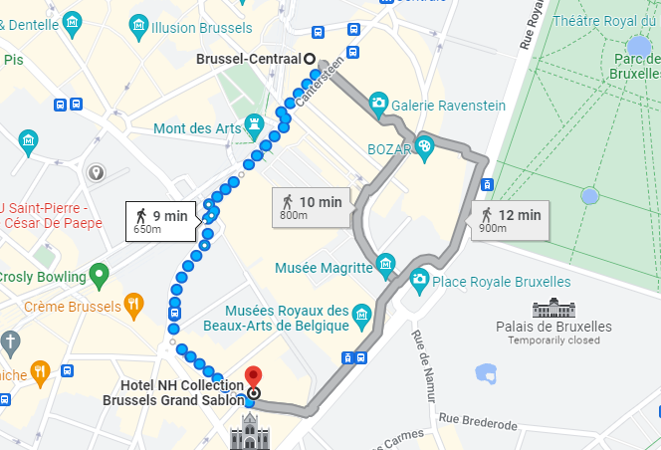

- Brussels including the airport

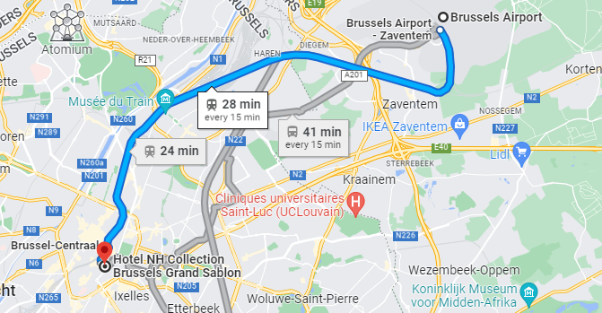

- Route to the Delirium Tremens Beer Tasting Event (Imp. De la Fidelite 4 1000 Brussels)

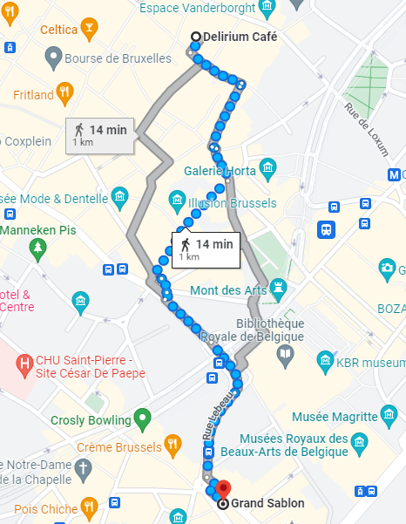

- Route to the University Club (Rue d’Egmont 11 1000 Brussels)

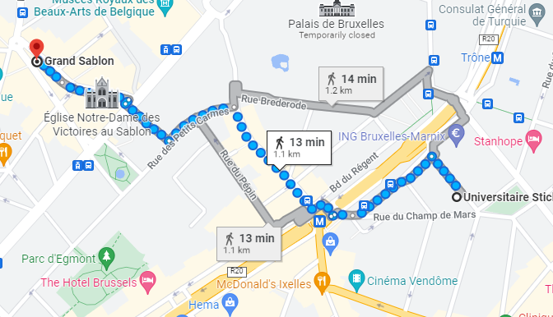

Getting to Brussels and the AGM Hotel

By Plane: Brussel Airport is approximately 8 miles from our hotel. There is a train from the airport to the Main Train Station in Brussels that runs every 15 minutes and takes about 30 minutes including walking. The train station is about 600 meters from the hotel. Alternatively, cab from the airport takes about 30-40 minutes depending on the time of day.

By Car: If you are inclined to drive, there is parking at the hotel. I am not sure on the price, but I assume that it is expensive.

By Train: In Europe traveling by train is a much better option than in the US. As mentioned above the Main Train Station in Brussels is about 600 meters from the hotel.

Wednesday June 8th
AGM Business Meeting |  |  | Virtual |  |  |  |  |  | Zoom Meeting
 |  |  |  |  |  |  |  |  | Willie Hendrickson (IFPRI)
Members and Consultants
7:30 | Call to Order |  |  |  | Willie Hendrickson (IFPRI)
7:40 | Reading of Minutes from last Meeting and Determination of Quorum |  |  |  | Matt Maille (KDRP)
7:50 | Financial Status and Budget |  |  |  | Willie Hendrickson (IFPRI)
8:20 | Membership Status and Invited Guests |  |  |  | Willie Hendrickson (IFPRI)
8:30 | Communication Report |  |  |  | Matt Maille (KDRP)
8:45 | Discussion of 2023 Winter Meeting and 2023 AGM at Purdue |  |  |  | Willie Hendrickson (IFPRI)
9:00 | Technical Program Status |  |  |  | Judith Bonsall (Unilever) and Jim Michaels (IFPRI)
9:15 | Planning and Other Business |  |  |  | Willie Hendrickson (IFPRI)
9:30 | Adjourn
Saturday June 11th
Happy Hour |  |  | Bar |  |  |  |  |  | NH Collection Grand Sablon Hotel
Members, Academics, Consultants, Guests, Accompanying Persons
 |  |  |  |  |  |  |  |  | 18:00 - 20:00
Sunday June 12th
Breakfast |  |  | Breakfast Restaurant |  |  |  |  |  | NH Collection Grand Sablon Hotel
Members, Academics, Consultants, Guests, Accompanying Persons
 |  |  |  |  |  |  |  |  | 7:00 - 9:00
Registration |  |  | Prefunction Lobby |  |  |  |  |  | NH Collection Grand Sablon Hotel
Members, Academics, Consultants, Guests, Accompanying Persons
 |  |  |  |  |  |  |  |  | From 8:00
AGM Welcome, IFPRI Project Overviews (Oral Presentatons and Poster Talks) |  |  | Plenary Room |  |  |  |  |  | NH Collection Grand Sablon Hotel
 |  |  |  |  |  |  |  |  | Judith Bonsall (Unilever), Chair
Members, Academics, Consultants, Guests
9:00 | Welcome and Introduction of Guests |  |  |  | Willie Hendrickson (IFPRI)
9:10 | Opening Comments |  |  |  | Judith Bonsall (Unilever)
9:20 | Welcome to KU Leuven |  |  |  | Erin Koos (KU Leuven - Belgium
Coffee Break |  |  | Prefunction Lobby |  |  |  |  |  | NH Collection Grand Sablon Hotel
Members, Academics, Consultants, Guests, Accompanying Persons
 |  |  |  |  |  |  |  |  | 10:00 - 10:30
10:30 | Horizons in Granular Modeling - Beyond DEM |  |  |  | Farang Radjai (University of Montpellier - France)
11:10 | Dynamic Flows in Powders and Grains |  |  |  | Nico Gray (University of Manchester - UK)
Lunch |  |  | Hotel Restaurant |  |  |  |  |  | NH Collection Grand Sablon Hotel
Members, Academics, Consultants, Guests, Accompanying Persons
 |  |  |  |  |  |  |  |  | 11:50 - 13:30
13:30 | Crystal Shape Prediction |  |  |  | Mike Doherty (University of California Santa Barbara - USA)
13:40 | Model Based Control of Crystallization |  |  |  | Zoltan Nagy (Purdue University - USA)
13:50 | Characterization of Spray Nozzles |  |  |  | Nasser Ashgriz (University of Toronto - Canada)
14:00 | Drying Kinetics and Morphology |  |  |  | Maciej Jaskulski (Lodz University - Poland)
14:10 | Simplified Industrial Formulations - Design Challenges |  |  |  | Jan Vermant (ETH Zurich - Switzerland)
14:20 | Simplified Industrial Formulations - Collaboration |  |  |  | Lillian Hsaio (North Carolina State University - USA)
Coffee Break |  |  | Prefunction Lobby |  |  |  |  |  | NH Collection Grand Sablon Hotel
Members, Academics, Consultants, Guests, Accompanying Persons
 |  |  |  |  |  |  |  |  | 14:30-14:45
14:45 | DEM Round Robin |  |  |  | Kit Windows Yule and Jonathan Seville (University of Birmingham - UK)
14:55 | Process and Product Models for Wet Granulation |  |  |  | Rachel Smith (University of Sheffield - UK)
15:05 | Poster Organization |  |  |  | Judith Bonsall (Unilever – UK)
15:15 | Poster Session Part I
Coffee Break |  |  | Prefunction Lobby |  |  |  |  |  | NH Collection Grand Sablon Hotel
Members, Academics, Consultants, Guests, Accompanying Persons
 |  |  |  |  |  |  |  |  | 15:45-16:00
16:00 | Poster Session II
Coffee Break |  |  | Prefunction Lobby |  |  |  |  |  | NH Collection Grand Sablon Hotel
Members, Academics, Consultants, Guests, Accompanying Persons |  |  |  |  |  |  | 17:00 – 17:15
17:15 | Poster Session III
17:45 | Adjourn for Day
Happy Hour and Beer Tasting Event |  |  | Delirium Tremens Café |  |  |  |  |  | Imp. De la Fideilite 4
Members, Academics, Consultants, Guests, Accompanying Persons
 |  |  |  |  |  |  |  |  | 18:30 - 20:00
Monday June 13th
Breakfast |  |  | Breakfast Restaurant |  |  |  |  |  | NH Collection Grand Sablon Hotel
Members, Academics, Consultants, Guests, Accompanying Persons
 |  |  |  |  |  |  |  |  | 7:00 - 8:00
Registration |  |  | Prefunction Lobby |  |  |  |  |  | NH Collection Grand Sablon Hotel
Members, Academics, Consultants, Guests, Accompanying Persons
 |  |  |  |  |  |  |  |  | From 8:00
Project Reviews (Poster Presentations) |  |  | Plenary Room |  |  |  |  |  | NH Collection Grand Sablon Hotel
 |  |  |  |  |  |  |  |  | Judith Bonsall (Unilever), Chair
Members, Academics, Consultants, Guests
8:30 | Session Introduction |  |  |  | Judith Bonsall (Unilever)
8:45 | Slurry and Paste Rheology |  |  |  |  |  |  | Erin Koos (KU Leuven - Belgium)
8:55 | Controlling Rheology via Boundary Conditions in Dense Granular Flows |  |  |  |  |  |  | Karen Daniels (North Carolina State University-USA)
9:05 | Modelling Powder Flow Through Screw Feeders |  |  |  |  |  |  | Prabhu Nott (Indian Institute of Science - India)
9:15 | Systems Engineering Approach to Dry Milling with Grinding Aids |  |  |  |  |  |  | Arno Kwade (TU Braunschweig - Germany
9:35 | Selection of Flow Aids |  |  |  |  |  |  | Raj Dave (New Jersey Institute of Technology - USA
Coffee Break |  |  | Prefunction Lobby |  |  |  |  |  | NH Collection Grand Sablon Hotel
Members, Academics, Consultants, Guests, Accompanying Persons
 |  |  |  |  |  |  |  |  | 9:35-10:05
10:05 | Wetting and Dispersion of Powders |  |  |  |  |  |  | Claire Gaiani (University of Lorraine - France
10:15 | Powder Adhesion to Metal Surfaces |  |  |  |  |  |  | Csaba Sinka (University of Leicester - UK
10:25 | Air-Induced Defect Formation During Compaction |  |  |  |  |  |  | Ken Kamrin (Massachusetts Institute of Technology - USA)
10:35 | Poster Session IV
Coffee Break |  |  | Prefunction Lobby |  |  |  |  |  | NH Collection Grand Sablon Hotel
Members, Academics, Consultants, Guests, Accompanying Persons
 |  |  |  |  |  |  |  |  | 11:35-11:50
11:50 | Poster Session Part V
Lunch |  |  | Hotel Restaurant |  |  |  |  |  | NH Collection Grand Sablon Hotel
Members, Academics, Consultants, Guests, Accompanying Persons
 |  |  |  |  |  |  |  |  | 12:50 – 13:50
13:45 | Feedback from Academics |  |  |  | Judith Bonsall (Unilever) and Jim Michaels (IFPRI)
Coffee Break |  |  | Prefunction Lobby |  |  |  |  |  | NH Collection Grand Sablon Hotel
Members, Academics, Consultants, Guests, Accompanying Persons
 |  |  |  |  |  |  |  |  | 15:20-15:50
Discussion of Projects and Quality Review of Renewal Projects |  |  | Plenary Room |  |  |  |  |  | NH Collection Grand Sablon Hotel
 |  |  |  |  |  |  |  |  | Judith Bonsall (Unilever), Chair
Members, Consultants, Guests
15:50 | Discussion of Current Projects and Quality Review of Renewal Proposals |  |  |  | Judith Bonsall (Unilever) and Jim Michaels (IFPRI)
17:50 | Adjourn for Day
Sporting Event –Car Racing and Dinner |  |  |  |  |  |  |  |  |  | Kart Inn
Meet in Front of Hotel for Buses
Members, Academics, Consultants, Guests, Accompanying Persons |  |  |  |  |  |  | 1815
Tuesday June 14th
Breakfast |  |  | Breakfast Restaurant |  |  |  |  |  | NH Collection Grand Sablon Hotel
Members, Academics, Consultants, Guests, Accompanying Persons
 |  |  |  |  |  |  |  |  | 7:00 - 8:30
Registration |  |  | Prefunction Lobby |  |  |  |  |  | NH Collection Grand Sablon Hotel
Members, Academics, Consultants, Guests, Accompanying Persons
 |  |  |  |  |  |  |  |  | From 8:00
Plenary Lectures, Prospective Member Talks |  |  | Plenary Room |  |  |  |  |  | NH Collection Grand Sablon Hotel
 |  |  |  |  |  |  |  |  | Judith Bonsall (Unilever), Chair
Members, Academics, Consultants, Guests
8:30 | Session Introduction |  |  |  | Judith Bonsall (Unilever)
8:35 | Highly-selective sensors by aerosol particle technology for detection of liquor adulteration and monitoring of body fat burning |  |  |  | Sotiris Pratsinis (ETH Zurich – Switzerland)
9:15 | Sonocrystallisation: effect of ultrasound frequency and power on induction times and crystal properties |  |  |  | Liian Liu (University of Surrey -UK)
9:55 | Prospective Member Talks |  |  |  | Willie Hendrickson (IFPRI)
Coffee Break |  |  | Prefunction Lobby |  |  |  |  |  | NH Collection Grand Sablon Hotel
Members, Academics, Consultants, Guests, Accompanying Persons
 |  |  |  |  |  |  |  |  | 10:35-11:05
11:05 | Consultant Update on Powder Flow and People of Interest |  |  |  | Michel Louge (Cornell University - USA)
11:13 | Consultant Update on Wet Systems and People of Interest |  |  |  | Eric Furst (University of Delaware- USA)
11:21 | Consultant Update on Systems Engineering and People of Interest |  |  |  | Satoru Watano (Osaka Prefecture University - Japan)
11:29 | Consultant Update on Formation and People of Interest |  |  |  | Karen Hapgood (Deakin University - Australia)
11:37 | Consultant Update on Size Reduction and People of Interest |  |  |  | Wolfgang Peukert (Friedrich-Alexander-Universität Erlangen-Nürnberg - Germany)
11:45 | Consultant Update on Characterization and People of Interest |  |  |  | Wilson Poon (University of Edinburgh - UK)
11:53 | Consultant Update on Education and People of Interest |  |  |  | Paul Mort (Purdue University - USA)
Lunch |  |  | Hotel Restaurant |  |  |  |  |  | NH Collection Grand Sablon Hotel
Members, Academics, Consultants, Guests, Accompanying Persons
 |  |  |  |  |  |  |  |  | 12:00 - 13:00
13:00 | Session Introduction |  |  |  | Jim Michaels (IFPRI) and Judith Bonsall (Unilever)
13:10 | Breakout into Small Group Discussions |  |  |  | All
Coffee Break |  |  | Prefunction Lobby |  |  |  |  |  | NH Collection Grand Sablon Hotel
Members, Academics, Consultants, Guests, Accompanying Persons
 |  |  |  |  |  |  |  |  | 15:00-15:15
15:15 | Idea Feedback |  |  |  | All
16:30 | Idea Refinement |  |  |  | All
18:00 | Adjourn for the Day
ADDICT Demo and Short Course |  |  | Plenary Room |  |  |  |  |  | NH Collection Grand Sablon Hotel
Members, Academics, Consultants, Guests, Accompanying Persons
 |  |  |  |  |  |  |  |  | 18:00 - 19:00
Dinner on your Own
Wednesday June 15th
Breakfast |  |  | Breakfast Restaurant |  |  |  |  |  | NH Collection Grand Sablon Hotel
Members, Academics, Consultants, Guests, Accompanying Persons
 |  |  |  |  |  |  |  |  | 6:00-7:30
Walk to University Club
Depart from Front of Hotel at 7:30
New Brief Presentations |  |  |  |  |  |  |  |  | Cattier Room University Club Rue d’Egmont 11 1000 Brussels
 |  |  |  |  |  |  |  |  | Judith Bonsall (Unilever), Chair
Members, Academics, Consultants, Guests
7:30 | Session Introduction |  |  |  | Judith Bonsall (Unilever)
7:35 | Presentation and Discussion of Refined Ideas for Future Programs/Reviews/ Workshops/etc |  |  |  | All
9:00 | Session Adjourns
Coffee Break |  |  |  |  |  |  |  |  | University Club
Members, Academics, Consultants, Guests, Accompanying Persons
 |  |  |  |  |  |  |  |  | 9:00-9:15
Selection Process for Projects Starting in 2022 - Part I |  |  | Cattier Room |  |  |  |  |  | University Club
 |  |  |  |  |  |  |  |  | Judith Bonsall (Unilever), Chair
Members, Consultants, Guests
9:15 | Session Introduction |  |  |  | Judith Bonsall (Unilever)
9:20 | Consultant Feedback on Proposals |  |  |  | All
9:55 | Discussion of Preferred Proposals for Dot Voting - New Projects |  |  |  | All
11:30 | Session Adjourn
Lunch |  |  | Mannix Room |  |  |  |  |  | University Club
Members, Academics, Consultants, Guests, Accompanying Persons, Students
 |  |  |  |  |  |  |  |  | 12:45 - 13:30
Student Poster Session |  |  | Cattier Room |  |  |  |  |  | University Club
 |  |  |  |  |  |  |  |  | Judith Bonsall (Unilever), Chair
Members, Academics, Consultants, Guests, Students
13:30 | Poster Session and Coffee |  |  |  | Judith Bonsall (Unilever)
16:00 | Announcement of Winning Student Posters |  |  |  | Willie Hendrickson (IFPRI)
16:15 | Session Adjourn
Banquet |  |  | Salon |  |  |  |  |  | University Club
Members, Academics, Consultants, Guests, Accompanying Persons
 |  |  |  |  |  |  |  |  | 18:30-21:00
Thursday June 16th
Breakfast |  |  | Breakfast Restaurant |  |  |  |  |  | NH Collection Grand Sablon Hotel
Members, Academics, Consultants, Guests, Accompanying Persons
 |  |  |  |  |  |  |  |  | 7:00 - 9:30
New Proposal Discussion and Voting |  |  | Plenary Room |  |  |  |  |  | NH Collection Grand Sablon Hotel
 |  |  |  |  |  |  |  |  | Judith Bonsall (Unilever), Chair
Members, Consultants, Guests
8:00 | Project Briefs and Proposals Available in Plenary Room for Reading
9:30 | Session Introduction and Establishment of Quorum |  |  |  | Judith Bonsall (Unilever)
9:40 | Dot Voting on Renewals and New Proposals Starting in September 2022 |  |  |  | Judith Bonsall (Unilever)
9:55 | Counting and Declaration of Rank Order for New Projects |  |  |  | Judith Bonsall (Unilever)
10:00 | Clarification of New Ideas and Reviews |  |  |  | Judith Bonsall (Unilever)
10:30 | Dot Voting for Reviews with working Coffee Break |  |  |  | Judith Bonsall (Unilever)
10:45 | Counting and Declaration of Rank Order for Reviews |  |  |  | Judith Bonsall (Unilever)
10:50 | Dot Voting for Workshops |  |  |  | Judith Bonsall (Unilever)
11:00 | Counting and Declaration of Rank Order for Workshops |  |  |  | Judith Bonsall (Unilever)
11:05 | Dot Voting for Briefs |  |  |  | Judith Bonsall (Unilever)
11:20 | Counting and Declaration of Rank Order for Briefs |  |  |  | Judith Bonsall (Unilever)
11:25 | Prospective Member Comments |  |  |  | Willie Hendrickson (IFPRI)
Lunch |  |  | Hotel Restaurant |  |  |  |  |  | NH Collection Grand Sablon Hotel
Members, Academics, Consultants, Guests, Accompanying Persons
 |  |  |  |  |  |  |  |  | noon-13:00
13:00 | Business Meeting an Establishment of Quorum |  |  |  | Willie Hendrickson (IFPRI)
13:05 | Set Budget from Rank Order of Proposals, Reviews, and Workshops |  |  |  | Willie Hendrickson (IFPRI)
15:00 | Discussion of Performance of Officers and Consultants |  |  |  | Judith Bonsall (Unilever)
16:00 | Any Other Business |  |  |  | Willie Hendrickson (IFPRI)
17:00 | Adjourn Meeting

