

9th IFPRI Workshop on Particle Technology –
Suspensions and Slurries: Insights from New Physics
June 22-23, 2018
James Clerk Maxwell Building
Kings Buildings
University of Edinburgh
Edinburgh, Scotland
Host: Wilson Poon (University of Edinburgh)
Co-Chairs: John Hone (Syngenta)
Marty Murtagh (Corning)
Scott Brown (Chemours)
Norm Wagner (University of Delaware)
Motivation and Scope
Suspensions and slurries represent a broad range of industrially important dynamic systems where the interplay between particle properties, surface properties, and system attributes can give rise to challenging flow, stability, and shelf-life issues. The storage, transport, handling and processing of suspensions and slurries are critical for a wide range of industries. Economic and sustainability drivers are calling for reduced solvent levels (increasing solids loading), prolonged shelf-life, while product performance and processing/handling expectations remain unchanged. This evolution is pushing conventional methods for slurry design to it limits and frequently requires new system-level and particle-level design considerations. To this effect, advances in understanding drivers for particle behaviors at high concentrations and under confinement are becoming increasingly important.

A priori prediction of flow and storage behavior of many industrially relevant slurries is simply not possible due to a range of complicating factors including chemical and physical property diversity and history dependent transformations that dynamically impact system behaviors. Dealing with the complexity of slurry systems containing diverse and heterogeneous materials offer challenges, such as heterocoagulation, intermediate shear dependent network transitions, stratification and other complex phenomena can embody themselves in different and unpredictable ways and impact important system level behaviors and product performance.

In order to advance the field and to begin to tackle persistent industrially relevant problems in the area of dense suspension and slurry systems, this workshop aims to bring thought leaders in academia and industrial scientists together to identify opportunities and prioritize research to advance the field.

This workshop will provide leading expert perspectives on the current state of the art of measurement, theory and simulation for predicting and understanding industrially relevant suspension, slurry and paste systems. It will also offer some new potentially transformative considerations to both theory and experiment, termed ‘New Physics’. Collectively, this workshop will gather a datum of the most pressing pre-competitive industrial problems within the area of dense slurries and suspensions for industry stakeholders and how advances in the state-of-the-science can be leveraged to make progress in the field.

Workshop Objectives:

- Identify, share and prioritize the most pressing problems in suspensions, slurries and pastes from an industry standpoint.
- Review recent advances in experimental and modeling tools/approaches used in academia to predict and design complex colloidal systems to control their behavior, establish the extent of this prediction and its limitations.
- Identify opportunities to leverage advances in the field and new approaches to address prioritized industry needs taking note of short term and long term efforts
- Develop a pre-completive research roadmap for slurries and colloids that is intended to address prioritized industry issues; and identify key near term projects that should best address current issues.

9th Workshop Notes and Directions
Like our previous AGM in Philadelphia I was not able to find a combined Hotel and Meeting Venue in the same building or site. While we were able to find very reasonable room rates, our workshop venue will require us to walk to and from the venue both days. We will be staying in rooms associated with the John McIntyre Conference Center where we will be having breakfast at the conference center café and meeting venue will be at the James Clerk Maxwell Building on the University of Edinburgh campus. The walk between the two sites is about 35 minute and is relatively flat (bring comfortable shoes for the meeting). Below I have attached maps for the sites that we will be walking to:
1) Thursday June 21th for the Pre-Meeting Happy Hour
Salisbury Arms
58 Dalkeith Road
Edinburgh EH16 5AD
44-131-667-4518

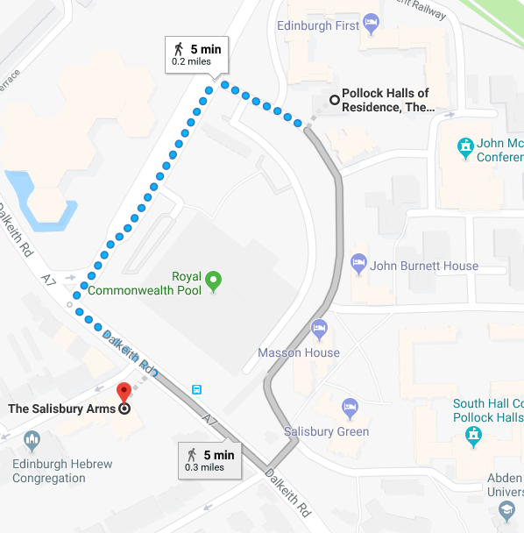

2) Friday and Saturday June 22th and June 23rd for the Workshop Meeting
James Clerk Maxwell Building, University of Edinburgh
Peter Guthrie Tait Road, King’s Buildings
Edinburgh EH9 3FD
44-131-650-5830
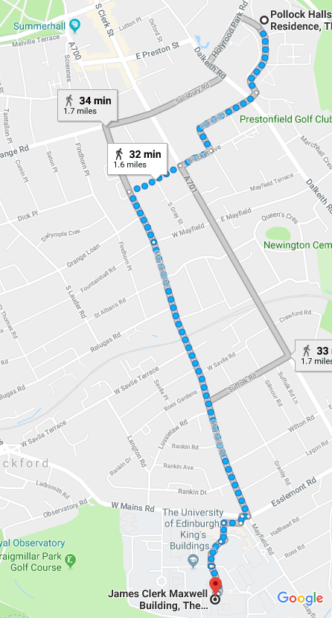
Thursday June 21st

Happy Hour |  |  | Salisbury Arms
Members, Academics, Consultants, Guests, Accompanying Persons |  |  |  |  |  |  |  |  |  |  |  |  |  |  |  | 1800-2000
 | Friday June 22nd
Breakfast |  |  | Café Lower Level John McIntyre Conference Center
All Attendees |  |  |  |  |  |  |  |  |  |  |  |  |  |  |  | 0630-1000
Registration |  | Outside Room 3217 James Clerk Maxwell Building
All Attendees |  |  |  |  |  |  |  |  |  |  |  | From 0800
Open Workshop |  |  |  | Room 3217 James Clerk Maxwell Building
All Attendees |  |  |  |  |  |  |  |  |  |  |  |  | John Hone, Chair
 | 0830 | Welcome |  |  |  |  |  |  |  |  |  |  | Willie Hendrickson (IFPRI)
 | 0835 | Welcome |  |  |  |  |  |  |  |  | Wilson Poon (University of Edinburgh –UK)
 | 0840 | Workshop Objective |  |  |  |  |  |  |  |  |  |  | John Hone (Syngenta – UK), Chair
Part I |  |  |  |  |  |  |  | Industrial Perspective
All Attendees |  |  |  |  |  | Marty Murtagh (Corning – USA), Chair
 | 0850 | Session Objective |  |  |  |  |  |  |  |  |  |  | Marty Murtagh (Corning – USA)
 | 0855 | Agribusiness Perspective |  |  |  |  |  |  |  |  |  |  | John Green (DuPont – USA)
 | 0915 | Food Structure Perspective |  |  |  |  |  |  |  |  |  |  | Bill Fritch (Unilever – UK)
 | 0935 | Industrial Materials Perspective |  |  |  |  |  |  |  |  |  |  | John Wight (Corning – USA)
 | 0955 | Similarities, Differences, & Priorities -  A Panel Discussion |  |  |  |  |  |  |  |  |  |  |  |  | Industry Presenters
 | 1020 | Coffee |  |  |  |  |  |  |  | Magnet Café, James Clerk Maxwell Building
Part II |  |  |  |  |  |  |  | Current State of Experimental Methods in Complex Colloidal Systems
All Attendees |  |  |  |  |  | Scott Brown (Chemours – USA), Chair
 | 1040 | Session Objective |  |  |  |  |  |  |  |  |  |  | Scott Brown (Chemours – USA)
 | 1045 | Coordinated Measurements of Particle Interactions, Microstructure, and Rheology in Colloidal Gels |  |  |  |  |  |  |  |  |  |  | Eric Furst (University of Delaware – USA)
 | 1105 | Methods to Characterize Microstructural Transitions in Suspensions |  |  |  |  |  |  |  |  |  |  | Erin Koos (Katholieke Universiteit Leuven – Belgium)
 | 1125 | Unsteady Flows in Dense Non Brownian Suspensions |  |  |  |  |  |  |  |  |  |  | Annie Colin ( École Supérieure de Physique et de Chimie Industrielles – France)
 | 1145 | Breakout Discussions |  |  |  |  |  |  |  |  |  |  |  |  | Locations and Format to be Announced in Meeting
 | 1315 | Group Feedback to Entire Meeting |  |  |  |  |  |  |  |  |  |  |  |  | Group Leads
Lunch |  |  |  |  | Magnet Café James Clerk Maxwell Building
All Attendees |  |  |  |  |  |  |  |  |  |  |  |  | 1245-1345
Part III |  |  |  |  |  |  |  |  | Current State of Theory and Simulation in Complex Colloidal Systems
All Attendees |  |  |  |  |  |  |  |  | Norm Wagner (University of Delaware – USA), Chair
 | 1345 | Session Objective |  |  |  |  |  |  |  |  |  |  |  | Norm Wagner (University of Delaware – USA)
 | 1350 | Modeling Dense Suspension Flows |  |  |  |  |  |  |  |  |  |  |  | Mike Cates (University of Cambridge – UK)
 | 1410 | New Perspectives on the Mechanism of Shear Thickening |  |  |  |  |  |  |  |  |  |  | Helen Wilson (University College London – UK))
 | 1430 | Kinetic Arrest in Colloids: From Gel Collapse to the Glass Transition |  |  |  |  |  |  |  |  |  |  | Roseanna Zia (Stanford University –USA)
 | 1450 | Breakout Discussions |  |  |  |  |  |  |  |  |  |  | Locations and Format to be Announced in Meeting
 | 1550 | Coffee |  |  |  |  | Magnet Café James Clerk Maxwell Building
 | 1610 | Breakout Discussions Continued |  |  |  |  |  |  |  |  |  |  | Locations and Format to be Announced in Meeting
 | 1640 | Feedback |  |  |  |  |  |  |  |  |  |  | Group Leads
 | 1720 | Close of First Day of Meeting

9th IFPRI Workshop Banquet New Club |  | 1930-2200
Members, Academics, Consultants, Guests, Accompanying Persons
 | Meet for Bus Trip to Edinburgh |  | 1900 Prompt Departure
 | Buses leave from the Front of John McIntyre Conference Center
 | Saturday June 23rd
Breakfast |  |  | Café Lower Level John McIntyre Conference Center
All Attendees |  |  |  |  |  |  |  |  |  |  |  |  |  | 0630-1000
Registration |  | Outside Room 3217 James Clerk Maxwell Building
All Attendees |  |  |  |  |  |  |  |  |  | From 0800
Open Workshop |  |  |  | Room 3217 James Clerk Maxwell Building
All Attendees |  |  |  |  |  |  |  |  |  |  | John Hone (Syngenta – UK), Chair
 | 0830 | Review of Yesterday’s Meeting |  |  |  |  |  |  |  |  | John Hone (Syngenta – UK)
Part IV |  |  |  |  |  |  | New Physics
All Attendees |  |  |  |  |  | Marty Murtagh (Corning – USA), Chair
 | 0840 | Session Objective |  |  |  |  |  |  |  |  | Marty Murtagh (Corning – USA)
 | 0845 | Structure Property Relations in Flocculated Suspensions – Insights form New Experimental Approaches |  |  |  |  |  |  |  |  | Jan Vermant (ETH, Zurich – Switzerland)
 | 0905 | Large Scale Simulation of Colloidal Hydrodynamics: Heterogeneous Particles, Structures and Flow Patterns |  |  |  |  |  |  |  |  | Jim Swan (MIT – USA)
 | 0925 | A Hydrodynamic Mechanism for Discontinuous Shear Thickening |  |  |  |  |  |  |  |  | John Brady (Caltech – USA)
 | 0945 | Coffee
 | 1005 | Breakout Discussion |  |  |  |  |  |  |  |  |  | Locations and Format to be Announced in Meeting
 | 1130 | Feedback |  |  |  |  |  |  |  |  |  | Group Leads
Lunch |  |  |  |  | Magnet Café James Clerk Maxwell Building
All Attendees |  |  |  |  |  |  |  |  |  |  | 1200-1315
Part V |  |  |  |  |  |  |  | Generating the Outputs
All Attendees |  |  |  |  |  |  |  | Scott Brown (Chemours – USA), Chair
 | 1315 | Session Objective |  |  |  |  |  |  |  |  |  |  | Scott Brown (Chemours – USA)
 | 1320 | Breakout Discussion on Next Steps
 | 1445 | Feedback |  |  |  |  |  |  |  |  | Group Leads
 | 1530 | Coffee |  |  |  |  |  |  | Magnet Café James Clerk Maxwell Building
 | 1545 | Reflections and Next Steps |  |  |  |  |  |  |  |  | Wilson Poon (University of Edinburgh – UK)  Norm Wagner (University of Delaware – USA)
 | 1600 | Feedback
 | 1615 | Meeting Closed

