

39th Annual General Meeting
June 18-22, 2017
Chemical Heritage Foundation
Philadelphia, Pennsylvania,
United States
Professor Antonios Zavaliangos Host
Drexel University

39th AGM Notes and Directions
This AGM will be different in format from previous meetings where the hotel and meeting venue were the same. Due to the difficulty of finding reasonable room rates and adequate meeting space I was forced to separate the rooms and the meeting venues, I apologize for the inconvenience, but we will get a bit of exercise from the daily walks to and from the meetings. Below I have attached walking maps for the sites that we will be walking to:
1) Saturday June 17th for the DEM Workshop and Happy Hour
Dave and Buster’s
325 N Christopher Columbus Blvd
215-413-1951

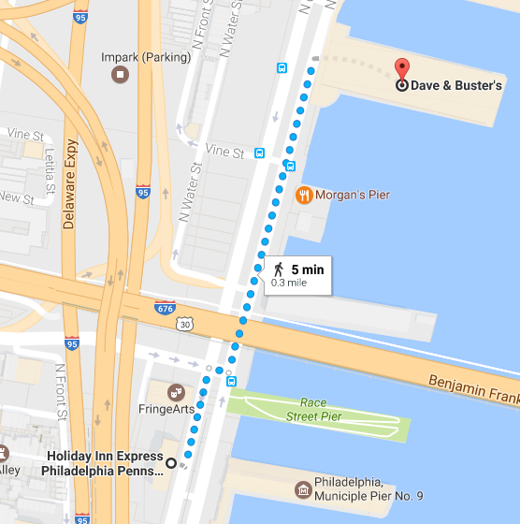

2) Sunday June 18th for the Sprit Cruise Dinner and Sporting Event. We will be taking a 2 and ½ hour dinner cruise on the Delaware River. Boarding is at 5:30 pm with the cruise being from 6-8:30 pm. The cruise will pass by the Naval Ship Yards and will highlight the Philadelphia Skyline at night from the river.
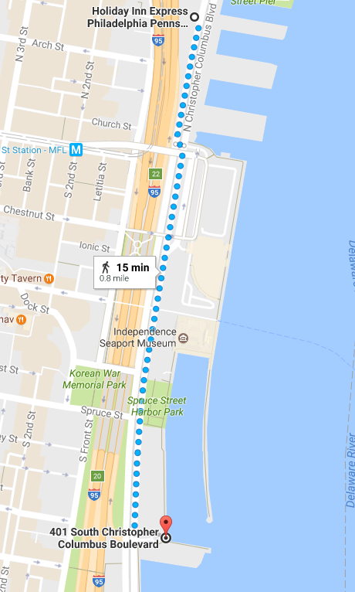

3) Sunday-Wednesday June 18-20, Thursday June 22 for the AGM Meeting Venue
Chemical Heritage Foundation
315 Chestnut Street
215-629-5356
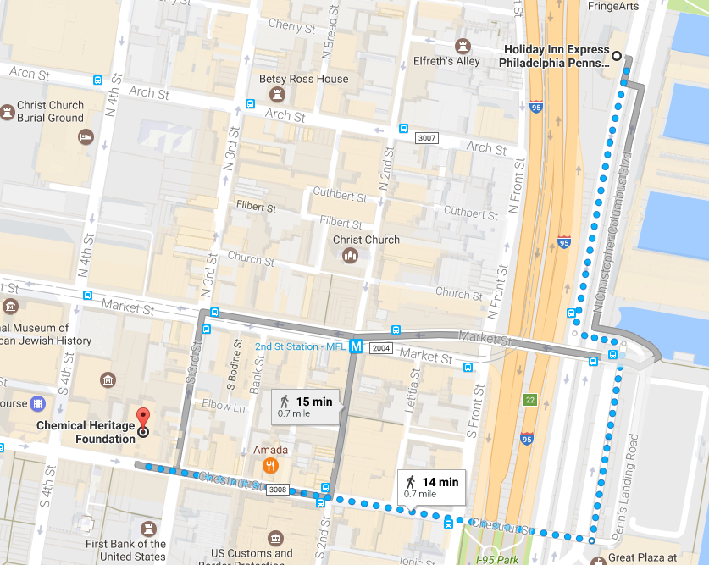

3 Wednesday June 21 Drexel University Hall
Buses will be provided from the Holiday Inn Hotel to Drexel (see agenda for timing)

4 Wednesday June 21 Banquet will be at the Barnes Foundation
Buses will be provided from the Holiday Inn to the Barnes Foundation (see agenda for timing)
2025 Benjamin Franklin Parkway
215-278-7000
Saturday June 17th
Discrete Element Modeling Roundtable Lunch |  |  |  | Dave and Buster’s
Members and Guests who have registered for roundtable |  |  |  |  | 1130-1230
Discrete Element Modeling Roundtable |  |  |  | Dave and Buster’s
Members and Guests who have registered for roundtable |  |  |  |  | 1230-1700
Happy Hour for Early Arrivals |  |  |  | Dave and Buster’s
Members, Academics, Consultants, Guests, Accompanying Persons |  |  |  |  | 1730-1900
Dinner |  |  | On Your Own
Members, Academics, Consultants, Guests, Accompanying Persons |  |  |  |  | 1900-

Sunday, June 18th
Breakfast Holiday Inn Express Breakfast Area
Members, Academics, Consultants, Guests, Accompanying Persons 0600-1000

Registration Chemical Heritage Foundation
Members, Academics, Consultants, Guests from 0800

Opening Business Meeting Ullyot Hall
Members, Consultants Willie Hendrickson, Chair
0830 Call to Order Willie Hendrickson (IFPRI)

0840 Reading of Minutes from Last Rajeev Gorowara (DuPont)
Meeting

0850 Financial Status and Budget Willie Hendrickson (IFPRI),

0910 Financial Secretary Discussion and Willie Hendrickson (IFPRI)
Nominations

0930 Membership Status and Willie Hendrickson (IFPRI)
Invited Guests

1000 Coffee Break

1015 Technical Program Status Judith Bonsall (Unilever),
Jim Michaels (IFPRI)

1045 Communication Report Rajeev Gorowara (DuPont)

1100 Planning and Other Business Willie Hendrickson (IFPRI)
Lunch Garden 2
Members, Academics, Consultants, Guests 1130-1230
Welcoming lunch for prospective and first-time IFPRI members

AGM Welcome and IFPRI Reviews Ullyot Hall
Members, Academics, Consultants, Guests Judith Bonsall (Unilever), Chair
1230 Welcome Willie Hendrickson (IFPRI)

1240 Opening Comments Judith Bonsall (Unilever)

1250 Die Filling and Powder Compaction Professor Antonios Zavaliangos
Drexel University
United States

1330 In-Line Sensors for Real-Time Analysis Professor Wuquiang Yang
Of Bulk Powders University of
Manchester Institute of Technology
United Kingdom

1410 Atomization of Highly-Viscous or Professor Nasser Ashgriz
Complex Fluids University of Toronto
Canada
1450 Coffee Break

1510 Particulate Engineering Gap Analysis Professor Stefan Heinrich
(preliminary report) Hamburg University of Technology
Germany

1530 Overview of Powder Flow Workshop Tim Bell
DuPont
Michel Louge
Cornell University

1550 Overview of Education Workshop Jim Michaels
University of Delaware
Jim Litster
University of Sheffield

1610 Overview of DEM Roundtable Prashant Gupta
P&G
1630 Adjourn

Sporting Event and Social Hour |  | Spirit Cruises
Members, Academics, Consultants, Guests, Accompanying Persons |  |  | 1730-1900

Monday, June 19th
Breakfast Holiday Inn Express Breakfast Area
Members, Academics, Guests, Accompanying Persons 0600-1000

Registration 0800
Members, Academics, Consultants, Guests

Project Reviews (Part I) Ullyot Hall
Members, Academics, Consultants, Guests Judith Bonsall (Unilever), Chair
0800 Session Introduction Judith Bonsall (Unilever)

0805 Creating Tuneable Agglomerates Professor Karen Hapgood
via 3D Printing Monash University
Australia

0825 Prediction of Segregation Professor Joe McCarthy
University of Pittsburgh
USA

0845 Powder Structure Control Professor Reinhard Kohlus
Hohenheim University
Germany

0915 Relating Compaction Performance Professor Antonios Zavaliangos & Behavior to Process Conditions Drexel University
USA

0925 Spray Drying at High Temperatures Professor Andrew Bayly
University of Leeds

0935 Flowability Assessment of Weakly Dr. Colin Hare and Dr. Ali
Consolidated Powders Hassanpour
University of Leeds
United Kingdom
9:45 Coffee

1015 Predicting Milling Behavior Professor Jin Ooi
University of Edinburgh
United Kingdom

1025 Die Filling of Aerated Powders Professor Charlie Wu
University of Surrey
United Kingdom

1035 Model-Based Control of Professor Zoltan Nagy
Crystallization Purdue University
United States

1055 Long Term Stability of Professor Wilson Poon
Colloidal Gels University of Edinburgh
United Kingdom

1105 Molecular Self Assembly Professor Uli Weisner
Cornell University

1115 Dry Powder Rheology Professor Karen Daniels
North Carolina State University
United States

1125 Introduction to Poster Presentations Willie Hendrickson (IFPRI)

1130 Poster Presentations

1230 Break for Lunch
Lunch Ullyot Hall
Members, Academics, Consultants, Guests 1240-1400

Project Reviews (Part II) |  |  |  |  |  |  | Ullyot Hall
Members, Academics, Consultants, Guests |  | Judith Bonsall (Unilever), Chair
1400 Poster Session Continuation

1530 Coffee

1600 Poster Session Continuation

Poster Feedback |  |  |  |  | Ullyot Hall
Members, Academics, Consultants, Guests |  |  | Judith Bonsall (Unilever), Chair
1700 Academic Feedback from Poster Talks

1800 Adjourn

Happy Hour and Dinner |  | To Be Announced
Members, Academics, Consultants, Guests, Accompanying Persons |  |  | 1830-2100
1830 Happy Hour Location To Be Announced

1930 Dinner On Your Own

Tuesday, June 20th
Breakfast Holiday Inn Express Breakfast Area
Members, Academics, Consultants, Guests, Accompanying Persons 0600-10000

Registration from 0800
Members, Academics, Consultants, Guests
MMe
Members Discussion of Projects |  |  | Ullyot Hall
Members, Consultants, Guests |  | Judith Bonsall (Unilever), Chair
 | 0800 Discussion
Discussion of Projects ,
Prospective Member Presentations |  |  | Ullyot Hall
Members, Academics, Consultants, Guests |  |  | Willie Hendrickson (IFPRI), Chair
0900 Introduction Willie Hendrickson (IFPRI)

0905 Prospective Member Presentations

1000 Break
New Project Proposal Discussion |  |  |  |  | Ullyot Hall
Members, Academics, Consultants, Guests |  |  |  | Judith Bonsall (Unilever), Chair
1030 Session Introduction Judith Bonsall (Unilever)

1035 Discussion of proposals

Lunch |  | Ullyot Hall
Members, Academics, Consultants, Guests |  |  |  |  |  | 1200-1330
Technical Planning Session |  |  | Ullyot Hall
Members, Academics, Consultants, Guests |  |  |  | Judith Bonsall (Unilever), Chair
1330 Introduction and Instructions

1340 Idea Generation (Projects/Workshops/Reviews)

1530 Coffee Break

1600 Idea Feedback

1700 Refine Ideas

1800 Adjourn

Dinner |  | On Your Own
Members, Academics, Consultants, Guests |  |  |  | 1900 -

Wednesday, June 21th
Breakfast Holiday Inn Express Breakfast Area
Members, Academics, Guests, Accompanying Persons 0600-1000

Registration | Drexel University
Members, Academics, Consultants, Guests, Students |  | 0800-0900

Professor Robert Pfeffer Symposium |  |  |  | Drexel University
Members, Academics, Consultants, Guests, Students |  |  |  |  | Professor Robert Pfeffer, Chair
0800 Buses Arrive Front of Holiday Inn Express

0900 Welcome Antonios Zavaliangos (Drexel University)

0905 Introduction Bob Pfeffer (Arizona State University)

0910 Forces, Stresses and the (Thermo?) John Brady (California Institute of dynamics of Active Matter Technology)

0950 To Be Added Sundar Sundaresan (Princeton Univeristy)

1040 Tea and Coffee Break

1110 MFIX Simulations of Gas-Solid Tingwen Li (AECOM/NETL)
Flow in Large Scale Fluidized
Bed Reactors

1150 Confinement-Induced Structural Darsh Wasan (Illinois Institute of Forces in Colloidal Dispersions Technology) and their Applications

Lunch |  | Drexel University
Members, Academics, Guests, Students |  |  |  |  |  |  | 1240-1330
Afternoon Presentations and Poster Session |  |  | Drexel University
Members, Academics, Guests, Students |  |  |  |  |  | Reg Davies (IFPRI Emeritus President), Chair
1330 - 1630 Poster Session

1530 Coffee and Tea

1630 Announcement of Student Award Winners

1640 Return to Holiday Inn Express

Banquet |  |  | The Barnes Foundation Museum
Members, Academics, Consultants, Guests, Accompanying Persons
1845 Meet in Holiday Lobby for bus ride to The Barnes Foundation

1900 Bus Ride

1930 Drinks and Hor D’oerves

2030 Dinner

2230 Return to Hotel

Thursday, June 22th
Breakfast |  | Holiday Inn Express Breakfast Area
Members, Academics, Consultants, Guests, Accompanying Persons |  |  |  | 0600-1000
Technical Program Selection Session |  |  | Franklin Room
Members, Consultants, Guests |  | Judith Bonsall (Unilever), Chair
0800 Call to Order and Introduction Judith Bonsall (Unilever)
With Agenda to be Presented

1000 Working Coffee Break

Prospective Member Comments |  | Franklin Room
Members, Guests, Consultants |  | Willie Hendrickson (IFPRI), Chair
 | 1230
Lunch
Members, Academics, Guests |  | 1245-1400
Final Business Meeting |  | Franklin Room
Members, Consultants |  | Willie Hendrickson (IFPRI), Chair
1400 New Financial Secretary Discussion Willie Hendrickson (IFPRI)
And Vote

1430 Membership Discussion Willie Hendrickson (IFPRI)

1500 2018 and 2019 AGM Site Willie Hendrickson (IFPRI)
Confirmation and Selection

1515 Final Budget Willie Hendrickson (IFPRI)

1545 Other Business All

1615 Adjourn

 | End of 2017 IFPRI AGM

