

11th IFPRI Workshop on Particle Technology
Modelling of Powder Flow

June 9-10, 2023
Holiday Inn City Centre Hotel
Lafayette, IN USA

Co-Chairs:
Konrad Herbst (Topsoe)
Michel Louge (Cornell University)
Navin Venugopal (Corning)
Jim Michaels (IFPRI)

Motivation and Objectives
The purpose of the PFW is to hold small group discussions on the state-of-the-art and challenges facing the modeling of powder flow. These discussions will be inspired by keynote talks from leading academic and industry representatives. The small groups will address the following three questions: (1) outline the state-of-the-art in powder flow; (2) how can qualitative predictions evolve toward a quantitative understanding that will allow system design at the industrial scale; and (3) define three scientific questions that IFPRI and other funding agencies should promote.

Workshop Format
There will be four half-day sessions with industrial and academic presentations followed by syndicate group discussions. Each session is focused on one of the following topics:

(1) outline the state-of-the-art in powder flow;
(2) how can qualitative predictions evolve toward a quantitative understanding that will allow system design at the industrial scale
(3) define three scientific questions that IFPRI and other funding agencies should promote.
Participants will be divided into syndicate groups to brain-storm the industrial and academic questions raised during the presentations. Each group has a syndicate leader who will report a summary of idea generations and brainstorming discussions of each group to all of the participants.

Virtual Format and Instructions

This meeting will be a hybrid meeting with a portion of the meeting highlighted in light gray being presented virtually. When you register for this meeting as a virtual attendee you will need to add Virtual in the Dietary preferences box. This will let me know to send you a zoom invite for the meeting.

11th Workshop Notes and Directions
This year the workshop will be held at the same location as the Annual General Meeting (AGM). Both meetings will be held in Lafayette, IN USA at the Holiday Inn City Centre. Like our last AGM held in 2022 in Brussels, Belgium, both the workshop and AGM will also be a hybrid meeting with portions of the meetings being both in-person and virtual. All times for the meeting are listed in US Central Daylight Savings Time (Chicago time). The sections highlighted in light gray will be available by zoom to those who are not able to attend the meeting in Lafayette. We also learned that having at least some portion of the meeting being virtual would allow more members to attend the meeting. Workshops have a limitation of only one attendee from each member company. There is no limit to the number of members or guests that can attend the workshop virtually, Please note that this will our second hybrid meeting with many of the presentations and discussions available as a Zoom broadcast. For the virtual sessions there will be a Zoom room to allow you to participate in the breakout discussions.
We will be in the Lafayette downtown area with a good variety of restaurants within walking distance.
As always, we will be having a number of happy hours during the meeting. On Thursday day June 8 we will have a welcoming happy hour at the Holiday Inn Centre City. On Friday June 9 we will combine our happy hour with the workshop banquet.
Below I have included a few maps that may be helpful:
The Address for the Holiday Inn City Centre is:
515 South Street
Lafayette, IN 47901
765-423-1000

- Downtown Lafayette, IN
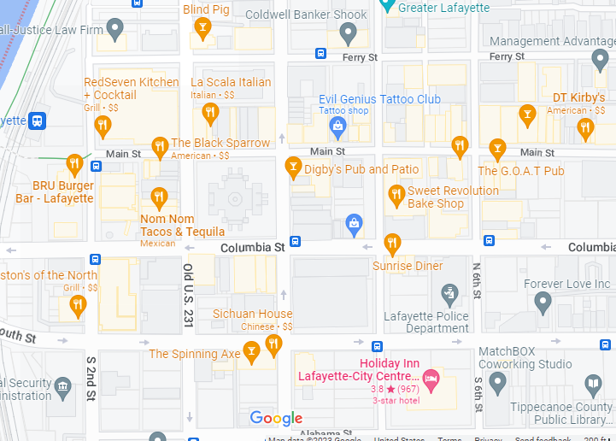

- Route to the hotel from Indianapolis, IN Airport
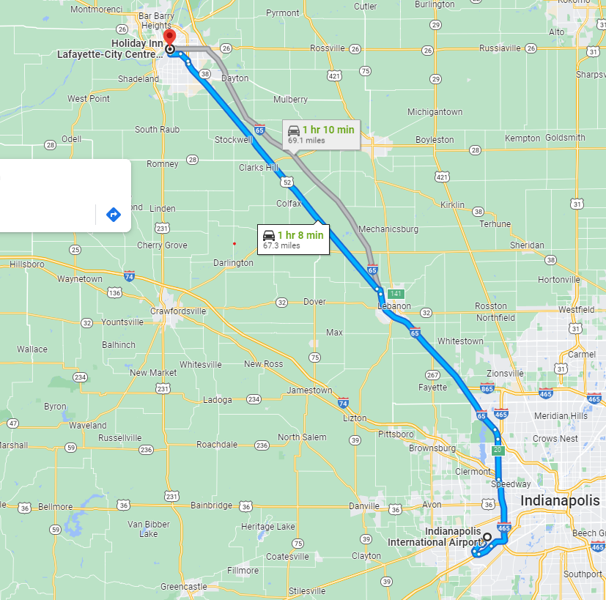

- Route to the hotel from Chicago, IL O’Hare Airport
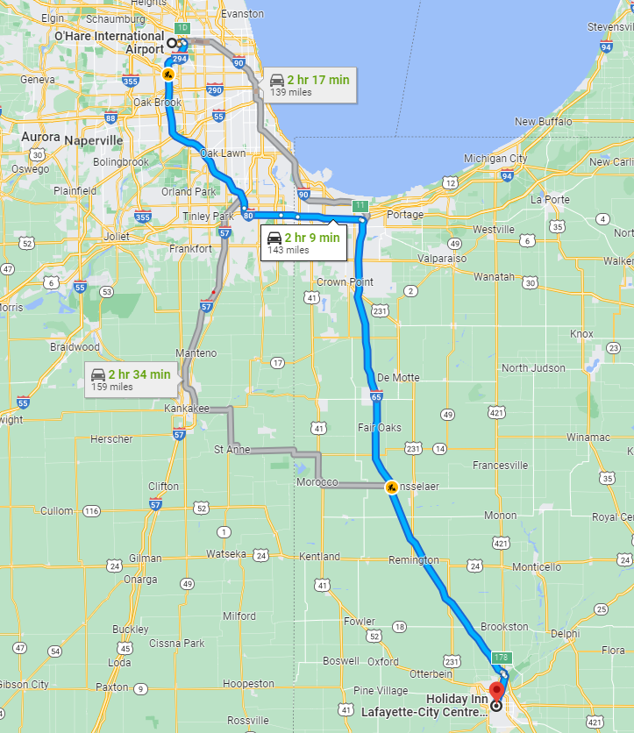

Getting to Lafayette and the AGM Hotel

By Plane: There are no commercial flights into Lafayette, IN. You will need to fly into Chicago, IL O’Hare Airport or Indianapolis, IN Airport and rent a car and drive to the hotel or reserve a seat on the shuttles from the airports to Lafayette. Driving time from Chicago is around 2 hours and is one hour from Indianapolis. In a quick look into flights from Europe I did not see any direct flights to Indianapolis. There were relatively cheap flights from Amsterdam via Philadelphia to Indianapolis.

By Car: If you are inclined to drive, there is free parking at the hotel.

Car Pooling: If you are interested in car pooling please let me know your interest and dates/times of arrival. I will be happy to connect interested parties.

By Shuttle from the airports: The following are some of the services that I found on-line from each airport. You will need to contact them directly.
Indianapolis Airport
Lafayette Limo 765-497-3828 ( https://www.lafayettelimo.com/services/90-shuttle-services) Leaves from the airport every two hours starting at 6:30 am until 10:30 pm Round trip price is $50 and the service will drop you off at the Holiday Inn City Centre.

Reindeer Shuttle 765-637-5124 (https://www.reindeershuttle.com/home/) Leaves from the airport at 7:15 am; 11:15 am; 3:15 pm and 5:15 pm. Round trip price is $60 and you will need to arrange cab from Lafayette drop off to hotel. I assume that you may be able to have the limo drop you off at the hotel, but it is not listed online.

Lyft I found one offer from the airport to Lafayette for $139 one-way.

O’ Hare Airport
Lafayette Limo 765-497-3828 ( https://www.lafayettelimo.com/services/90-shuttle-services) Leaves the airport at 8:00 am, 2:00 pm and 7:00 pm Round trip price is $110. The shuttle will drop you off at the Limo Office and you will need to arrange a cab to the hotel. I I assume that you may be able to have the limo drop you off at the hotel, but it is not listed online. Please note that this service is done only when there are reservations. Please reserve a spot early.

Reindeer Shuttle 765-637-5124 (https://www.reindeershuttle.com/home/) Leaves from the airport at 7:15 am; 11:15 am; 3:15 pm and 5:15 pm. Round trip price is $120 and you will need to arrange cab from Lafayette drop off to hotel. I assume that you may be able to have the limo drop you off at the hotel, but it is not listed online.

Thursday June 8

Happy Hour |  |  | Holiday Inn City Centre Bar
Members, Academics, Consultants, Guests, Accompanying Persons |  |  |  |  |  |  |  |  |  | 1800-2000
Friday June 9
Breakfast |  |  | Pittman Block Holiday Inn City Centre Hotel
All Attendees |  |  |  |  |  |  |  |  |  | 0630-1000
Registration |  | Outside Grand Ballroom Holiday Inn City Centre Hotel
All Attendees |  |  |  |  |  |  |  |  | From 0800
Workshop Opening |  |  |  | Grand Ballroom Holiday Inn City Centre Hotel
All Attendees |  |  |  |  |  |  |  | Michel Louge (Cornell University - USA), Chair
 | 0800 | Welcome |  |  |  |  |  | Willie Hendrickson (IFPRI)
 | 0805 | Workshop Objective, Format and Survey Results |  |  |  | Michel Louge (Cornell University – USA)
Grand Ballroom Holiday Inn City Centre Hotel
Session I |  |  |  |  |  |  | Modeling of Powder Flow
All Attendees |  |  |  |  | Michel Louge (Cornell - USA), Chair
 | 0820 | Session Objective |  |  |  |  |  | Michel Louge (Cornell University – USA)
 | 0825 | Using Experiments and Simulations to Conquer Industrial Solids Flow Problems |  |  |  |  |  | Pieter Vonk and Eric Grolman (DSM – The Netherlands)
 | 0855 | Continuum Modeling of Granular Flows? |  |  |  |  |  | Nico Gray (University of Manchester – UK)
 | 0925 | Dense Particulate Flows with Wet Particle-Particle Interactions – Current Status and Challenges |  |  |  |  |  | Hans Kuipers (Eidhoven University of Technology – The Netherlands)
 | 0955 | Boundary Interactions in Three-Dimensional Granular Flows |  |  |  |  |  | Alexandre Valance (University of Rennes – France)
 | 1025 | Coffee |  |  |  |  |  | Outside Grand Ballroom
Grand Ballroom Holiday Inn City Centre Hotel
Brainstorming Session I |  |  |  |  |  |  | Outline the State-of-Art in Powder Flow
All Attendees |  |  |  |  | Michel Louge (Cornell University), Chair
 | 1045 | Session Organization, Objectives and Room Assignments |  |  |  |  |  | Michel Louge (Cornell University– USA)
 | 1050 | Group I Pittman Block |  |  |  |  |  | Olivier Desjardins (Cornell University – USA)
 | 1050 | Group II Mezzanine |  |  |  |  |  | Douglas Jerolmack (University of Pennsylvania – USA)
 | 1050 | Group III Shambaugh Room |  |  |  |  |  | Nathalie Vriend (University of Colorado - USA)
 | 1050 | Group IV Purdue Room |  |  |  |  |  | Arno Kwade (TU Braunschweig – Germany)
 | 1050 | Group V Spears Room |  |  |  |  |  | Alberto Cuitiño (Rutgers University - USA
 | 1050 | Group VI Grand Ballroom |  |  |  |  |  | Prahbu Nott (Indian Institute of Science – India)
 | 1050 | Group VII Virtual |  |  |  |  |  | Jim Michaels (IFPRI – USA)
 | 1200 | Presentations by Syndicate Leaders
Lunch Pittman Block

All Attendees
1240-1340
Grand Ballroom Holiday Inn City Centre Hotel
Session II |  |  |  |  |  |  | Dense Powder Flow
All Attendees |  |  |  |  | Konrad Herbst (Topsoe – Denmark), Chair
 | 1340 | Session Objective |  |  |  |  |  | Konrad Herbst (Topsoe – Denmark)
 | 1345 | State-of-the-Art of Gas-Solids Flow - an Industrial Perspective |  |  |  |  |  | Ted Knowlton (PSRI – USA)
 | 1415 | Influence of Particle Shape on the Statics and Dynamics of Granular Materials |  |  |  |  |  | Farhang Radjai (University of Montpellier – France)
 | 1445 | On the Coupling of Computational Fluid Dynamics with Discrete Element Modelling |  |  |  |  |  | Berend van Wachem (Imperial College – UK)
 | 1515 | Recent Progress in Simulation and Modeling of Gas-Particle Flows |  |  |  |  |  | Jesse Capecelatro (University of Michigan – USA)
 | 1545 | Coffee |  |  |  |  |  | Outside Grand Ballroom

Grand Ballroom Holiday Inn City Centre Hotel
Brainstorming Session II |  |  |  | How can qualitative predictions evolve toward a quantitative understanding that will allow system design at the industrial scale?
All Attendees |  |  | Konrad Herbst (Topsoe), Chair
 | 1605 | Session Organization, Objectives and Room Assignments |  |  | Konrad Herbst (Topsoe – Denmark)
 | 1610 | Group I Pittman Block |  |  | Olivier Desjardins (Cornell University – USA)
 | 1610 | Group II Mezzanine |  |  | Douglas Jerolmack (University of Pennsylvania – USA)
 | 1610 | Group III Shambaugh Room |  |  | Nathalie Vriend (University of Colorado - USA)
 | 1610 | Group IV Purdue Room |  |  | Arno Kwade (TU Braunschweig – Germany)
 | 1610 | Group V Spears Room |  |  | Alberto Cuitiño (Rutgers University - USA
 | 1610 | Group VI Grand Ballroom |  |  | Prahbu Nott (Indian Institute of Science – India)
 | 1610 | Group VII Virtual |  |  | Jim Michaels (IFPRI -USA )
 | 1720 | Presentations by Syndicate Leaders
 | 1800 | Remarks on Overall Progress |  |  | Willie Hendrickson (IFPRI - USA)

11th IFPRI Workshop Banquet and Happy Hour  Location To Be Announced | 1830-2200
Members, Academics, Consultants, Guests, Accompanying Persons
 |  |  | Saturday June 10
Breakfast |  |  |  |  | Pittman Block Holiday Inn City Centre Hotel
All Attendees |  |  |  |  |  |  |  |  |  |  |  | 0630-1000
Registration |  |  |  | Outside Grand Ballroom Holiday Inn City Centre Hotel
All Attendees |  |  |  |  |  |  |  |  |  |  | From 0800
Workshop Opening |  |  |  |  |  | Grand Ballroom Holiday Inn City Centre Hotel
All Attendees |  |  |  |  |  |  |  |  |  | Navin Venugopal (Corning) Chair
 | 0815 |  | Day 1 Recap |  |  |  |  | Navin Venugopal (Corning – USA)
Grand Ballroom Holiday Inn City Centre Hotel
Session III |  |  |  |  |  |  |  |  | Powder Flow
All Attendees |  |  |  |  |  |  | Navin Venugopal (Corning - USA), Chair
 | 0820 |  | Session Objective |  |  |  |  |  |  | Navin Venugopal (Corning – USA)
 | 0830 |  | Research Gaps in Powder Flow: Purpose-Driven Particle Scale Product Design to Solve Process Issues |  |  |  |  |  |  | Kerry Johanson (Material Flow Solutions – USA)
 | 0900 |  | Continuum Modeling and Simulation of Dry and Wet Granular Media |  |  |  |  |  |  | Ken Kamrin (Massachusetts Institute of Technology – USA)
 | 09:30 |  | Complex dynamical transitions in granular flow: Augmented intelligence models for real-time decision making at field scale and beyond |  |  |  |  |  |  | Antoinette Tordesillas (University of Melbourne - Australia)
 | 1000 |  | Coffee |  |  |  |  |  |  | Outside Grand Ballroom

Grand Ballroom Holiday Inn City Centre Hotel
Brainstorming Session III |  |  |  | Define three scientific questions that IFPRI and other funding agencies should promote.
All Attendees |  |  | Navin Venugopal (Corning – USA ), Chair
 | 1030 | Session Organization, Objectives and Room Assignments |  |  | Navin Venugopal (Corning - USA)
 | 1040 | Group I Pittman Block |  |  | Olivier Desjardins (Cornell University – USA)
 | 1040 | Group II Mezzanine |  |  | Douglas Jerolmack (University of Pennsylvania – USA)
 | 1040 | Group III Shambaugh Room |  |  | Nathalie Vriend (University of Colorado - USA)
 | 1040 | Group IV Purdue Room |  |  | Arno Kwade (TU Braunschweig – Germany)
 | 1040 | Group V Spears Room |  |  | Alberto Cuitiño (Rutgers University - USA
 | 1040 | Group VI Grand Ballroom |  |  | Prahbu Nott (Indian Institute of Science – India)
 | 1040 | Group VII Virtual |  |  | Jim Michaels (IFPRI – USA)
 | 1150 | Presentations by Syndicate Leaders
Lunch Pittman Block

All Attendees
1230-1330

Grand Ballroom Holiday Inn City Centre Hotel
Session IV |  |  |  | Panel Discussion and Concluding Remarks
All Attendees |  |  | Michel Louge (Cornell University - USA), Moderator and Chair
 | 1330 | Introduction to Panel Discussion and Workshop Synthesis Discussion |  |  | Michel Louge (Cornell University - USA)
 | 1340 | Workshop Synthesis Discussion |  |  | All Attendees
 | 1440 | Panel Discussion and Reflection on the Three Questions |  |  | Olivier Pouliquen (Aix-Marseille University - France)  Kit Windows-Yule (University of Birmingham - UK)  Ted Knowlton (PSRI – USA)  Kerry Johanson (Material Flow Solutions – USA)  Karl Jacob (University of Michigan – USA)
 | 1540 | Concluding Remarks |  |  | Willie Hendrickson (IFPRI -USA)  Jim Michaels (IFPRI – USA)
 | 1550 | Adjourn Workshop
 | 1600 | Archiving Results |  |  | Organizing Committees and Any Others

